**LAB CYCLE 3**

# QUESTION SET 3 date:03-08-2021

Create the following tables.

* Primary key, SSN of EMPLOYEE should be created as a sequence starting at 1.
* There should be at least 8 employees and 5 departments
* Check salary range of employees is between 30,000 and 75,000 using check predicate.

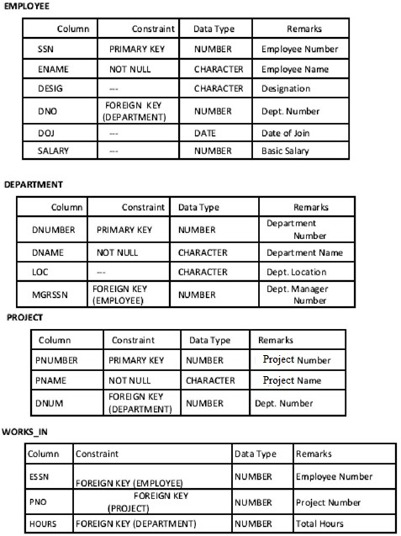

1. Retrieve all employees in department 5 whose salary is between Rs

30,000 and Rs 40,000.

**Output**

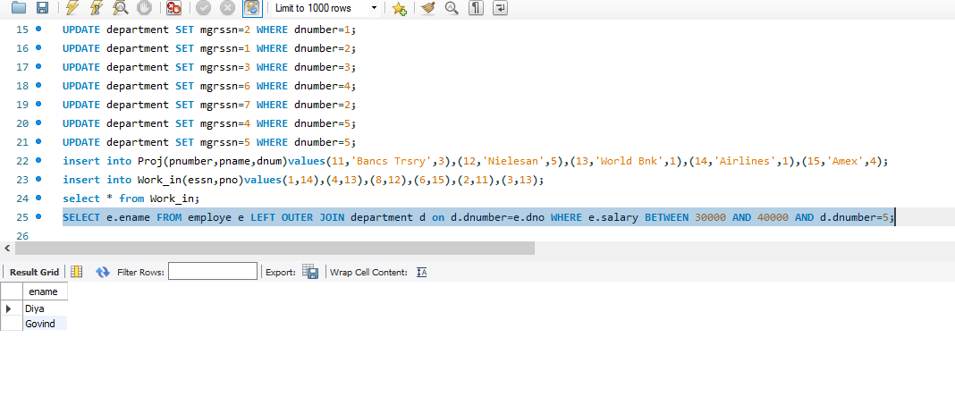

1. Retrieve a list of employees and the projects they are working on, where the departments and the employees within the department are alphabetically by name.

**Output**

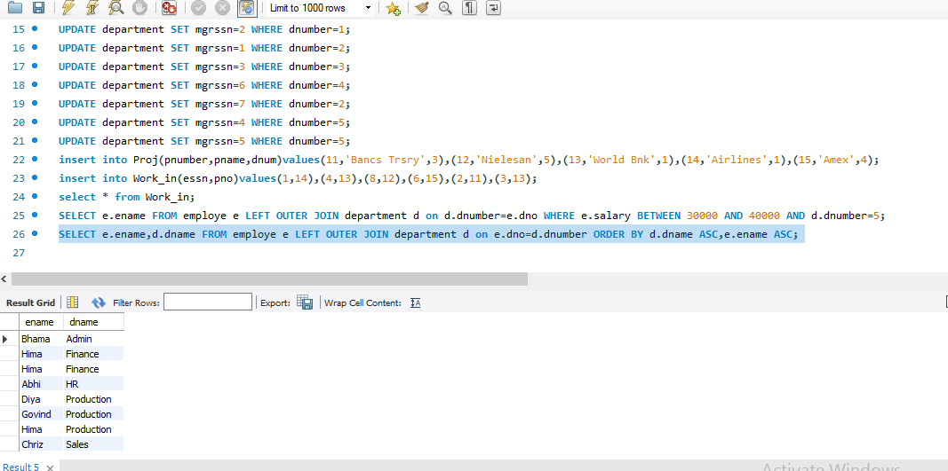

1. Retrieve the project number, the project name, and the number of employees who work in each project.

**Output**

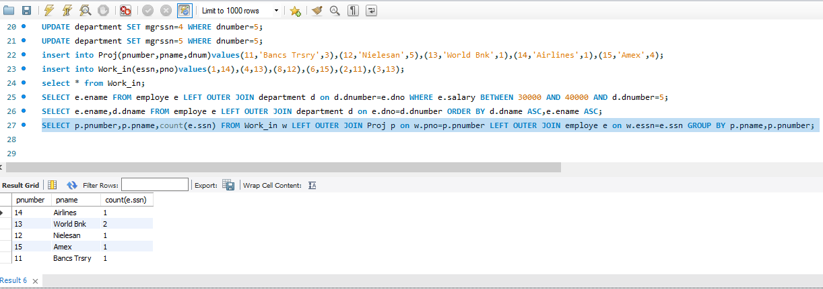

1. For the project on which more than two employees work, retrieve the project number, the project name, and the number of employees who work on the project.

**Output**

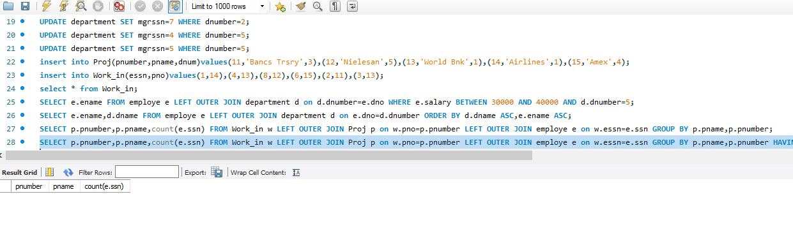

1. For each project, retrieve the project number, the project name, and the number of employees from department 5 who work on the project.

**Output**

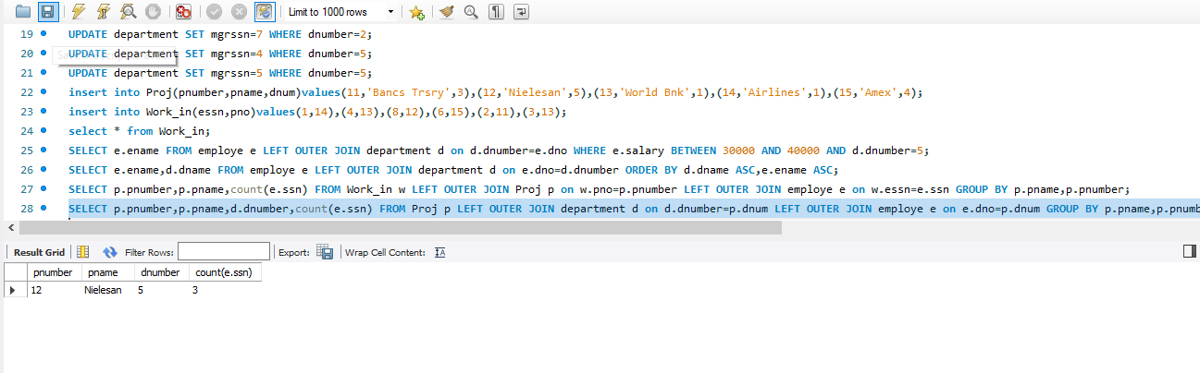

1. For the departments having more than five employees, display the department id and the number and details of employees earning more than Rs 40,000 per month.

**Output**

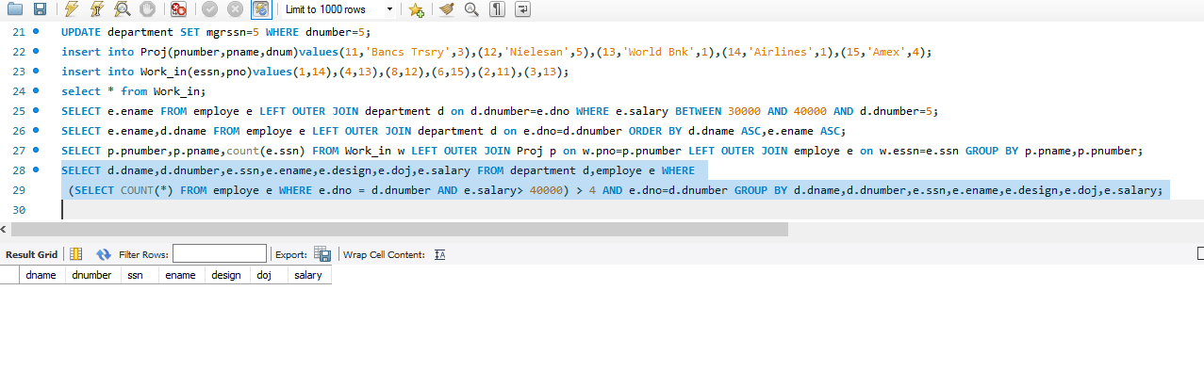

1. Create a synonym for the VIEW created on natural join of emp and dept tables.

**Output**

1. Use the tables Employee, and Department. Perform the operations as mentioned below:
   1. Display the employee details, departments that the departments are same in both the emp and dept. (Equi-join)

**Output**

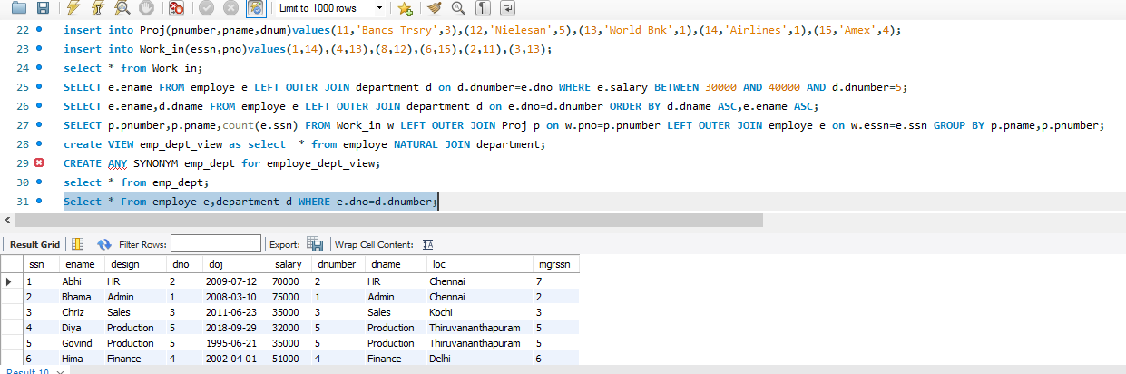

* 1. Display the employee details, departments that the departments are not same in both the emp and dept. (Non Equi-join)

**Output**

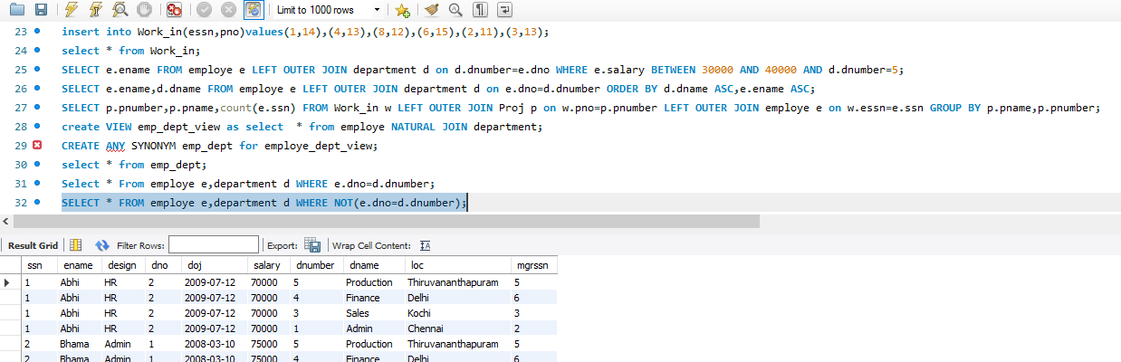

* 1. Perform Left outer join on the emp and dept tables.

**Output**

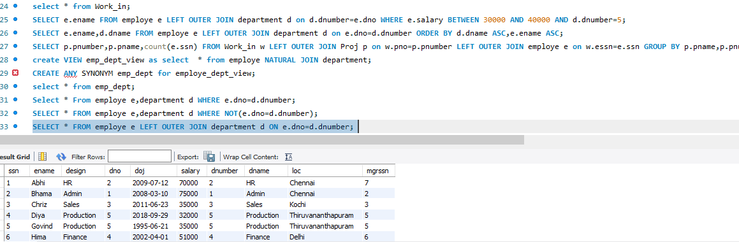

* 1. Perform Right outer join on the emp and dept tables.

**Output**

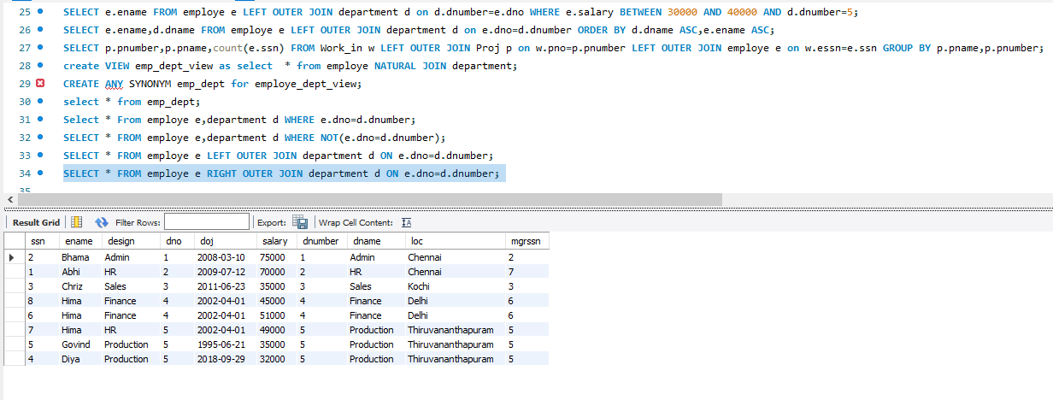

* 1. Perform inner join on the emp and dept tables.

**Output**

